

Lost at Sea

You are on the yacht with a team of three other able sailors. It has been 10 days at sea since you left Europe, so you are roughly halfway across the Atlantic Ocean. Unfortunately in mid Atlantic, a fierce fire breaks out in the ship’s galley. Most of the vessel has been destroyed, and you are slowly but surely sinking.

Your location is unclear because all navigational and radio equipment have been damaged beyond repair in the fire. Your best estimate is that you are several hundred miles from land. Between you, you’ve managed to save 15 items, undamaged and intact after the blaze. In addition, you have salvaged a four man rubber life raft and a single box of matches. You will have to drift, following the currents, and hope for a speedy rescue.

Your task is to rank the 15 items in terms of their importance for you, as you wait to be rescued. Number 1 is the most important item, number 2 is the second most important etc until you have ranked all 15 items.

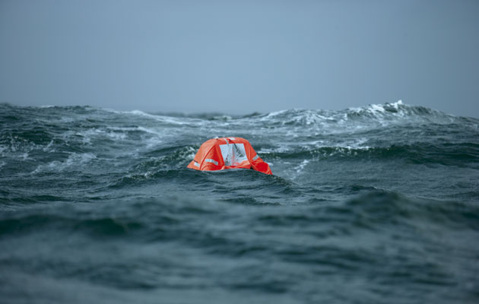

Trainer Instructions

1. Provide a ranking chart for every member of your group.

2. Ask each person to take 10 minutes to decide their own rankings, and record the choices in the Step 1 column.

3. Split the group into teams of 4. Encourage the groups to discuss their individual choices and work together to agree on a collaborative list. Allow 20 minutes for this section. Record the group rankings in the second column.

4. The correct answers were suggested by the US Coastguard. Display the ‘expert’ rankings on a PowerPoint presentation, whiteboard or photocopy.
Compare your individual and group answers with the correct answers and determine a score.

5. For each item, mark the number of points that your score differs from the
Coastguard ranking and then add up all the points, regardless of which score is higher or lower. The lower the total, the better your score.

6. As the groups work together, sharing thoughts and ideas, this should produce an improved score over the individual results. Discuss with your group why the scores were different? What changed their minds? And was this enough to survive?

Lost at Sea Rankings
4
Items | Step 1 | Step 2 | Step 3 | Step 4 | Step 5
Items | Your  ranking | Team  ranking | Coast  Guard  ranking | Difference  between  Step 1&3 =Your score | Difference  between  Step 2&3 =Team score
A sextant
A shaving mirror
Large mosquito
nets
A 25 litre jerry can of water
A case of army rations
Map of the Atlantic
Ocean
A floating seat cushion
A 10 litre can of
oil/petrol mixture
A transistor radio
20 sq feet of plastic sheeting
A can of shark repellent
One bottle of 80%
proof rum
15ft nylon rope
2 boxes of chocolate
bars
Fishing kit with pole
 |  |  | Totals:
Coastguard expert opinion

According to the US Coastguard, the basic supplies needed when stranded mid-ocean are things that will attract attention and support survival until help arrives. A transatlantic voyage takes roughly 20 days; significantly less with good winds and significantly more without them.
All navigational tools are useless, because even if a life raft were capable of reaching land, it would be impossible to store enough food and water to survive for that long. Your best chance of survival is to be found and rescued, and without signalling devices, the chance of being spotted is close to zero. With this in mind, the list below is the ranking order of the items according to their importance to your survival:

Item | Rank | Coastguard’s Reasons
A sextant | 15 | Absolutely useless without the relevant tables and a chronometer.
A shaving mirror | 1 | The mirror is absolutely crucial. It is the most powerful tool you have for communicating your presence. In sunlight, a mirror can generate 5 to 7 million candlepower of light. The reflected sunbeam can even be seen beyond the horizon.
A large mosquito  net | 14 | There aren’t any mosquitoes in the middle of the Atlantic Ocean and the net has no other use.
A 25 litre jerry can of water | 3 | Vital to restore fluids lost through perspiration. 25 litres will supply water rations for your group for several days.
A case of army rations | 4 | This is your basic food intake.
Maps of the Atlantic  Ocean | 13 | Worthless without navigation equipment.
A floating seat cushion | 9 | Useful as a life preserver if someone fell overboard.
A 10 litre can of  oil/petrol mixture | 2 | The second most critical item for signalling. It will float on water and can be ignited with the matches.
A transistor radio | 12 | You would be out of range of any radio station.
20 sq feet of plastic sheeting | 5 | Can be used to collect rain water and shelter from the wind and waves.
A can of shark repellent | 10 | To repel sharks, of course!
One bottle of 80%  proof rum | 11 | Contains 80% alcohol, which means it can be used as an antiseptic for any injuries, otherwise worthless. Very dangerous if drunk, as it would dehydrate you, the opposite of what you need to survive.
15ft nylon rope | 8 | Could be used to lash people or equipment together to prevent being washed overboard. There are a plethora of other uses, but none pertinent for survival.
2 boxes of chocolate  bars | 6 | Your reserve food supply
Fishing kit with pole | 7 | Ranked lower than the chocolate as there is no guarantee you will catch any fish. The pole might be used as a tent pole.

Scores

00 - 25 Excellent
You demonstrated fantastic survival skills. Rescued the next day!

26 - 32 Good
Above average results. Good survival skills. Rescued!

33 - 45 Average
Seasick, tired, hungry and grumpy. Rescued!

46 - 55 Fair
Dehydrated and barely alive. It was tough, but rescued!

56 - 70 Poor
Rescued, but just in the nick of time!

71 + Terrible
Alas, the empty raft is washed up on a beach, months after the search was called off.

