Useful Information about Personal Kit for DofE Participants
DofE Expedition Personal Clothing
There is an element of personal preference in expedition clothing, but there are 3 key principles:
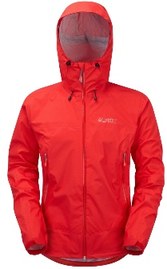
- Use multiple layers – provides more insulation and better regulation of body temperature.
- Stay dry
- Choose suitable materials – synthetic fibres offer good insulation and are lightweight, absorb less water and dry quicker.
Outer layer
- Acts like a shell, providing protection against wind and rain.
- You need a waterproof jacket which is both waterproof and breathable, allowing sweat to escape and keeping you dry.
- You will also need a pair of waterproof over-trousers.
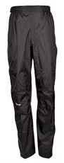
- For expeditions through boggy terrain, you may want gaiters to keep your feet dry.
Middle layer
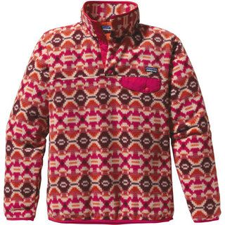
- Insulating, lightweight, windproof and quick drying.
- Fleeces are popular as they absorb little moisture.
- Trousers give protection against stings, bites and sunburn.
- Check the manufacturer’s label and avoid natural fabrics, such as cotton, which retain moisture and prevent sweat from escaping. Do NOT wear jeans.
Base layer
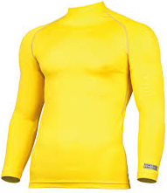
- Needs to draw sweat away from the skin.
- Football tops or sports tops are generally suitable for expeditions.
Hat and Gloves
- Cold weather – gretains heat and keep participants warm, and dry.
- Hot weather – a light, wide-brimmed hat protects the head, neck and face from sunburn.
Top tips for Clothing & Equipment

- The best source of equipment is to borrow from family & friends, if anyone has done DofE expeditions or similar recently. Avoid borrowing walking boots as these will have moulded to the owner’s feet, not yours!
- When shopping for kit and clothing, take your DofE pack with you and ask for discount.
- Shop around, compare prices, and use the internet to find the best deal.
- Take advantage of clearance sales to get best prices.
- Take someone with you who can make sure what you buy is fit for purpose.

Below is a list of retailers where you can buy items for DofE Expeditions

Cotswold Outdoors | 15% discount on all clothing and kit
Yeomans Outdoors | 10% discount on all clothing and kit
GO Outdoors | Discounts on RRP with £5 card
Decathalon | Clothing
Blacks | Clothing and equipment
Outside | Clothing and equipment
Millets | Clothing and equipment

Walking boots
No other equipment will have a greater impact on the enjoyment of an expedition. Boots are the most important piece of walking kit, so get the best fit you can. If boots don’t fit properly, you won’t have support for your feet and ankles, and will be prone to blisters, chafing and cramps. Too big and they’ll rub, too small and your toes will be scrunched up.
Here are our top tips for buying walking boots:
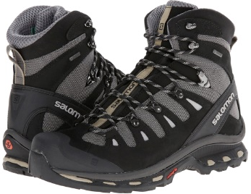
- You need boots that have ankle support to protect your ankle from twisting and sprains. Please do not wear trainers or trek shoes.
- Check that your boots have a hard-wearing sole that is injection moulded and won’t tear away from the upper part of the boot.
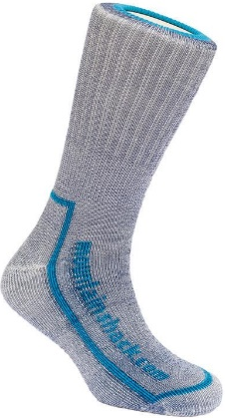
- Understand how your boot is waterproof, and what you need to treat the boots with to retain that waterproofing (eg Nikwax, Graingers etc). All boots need to be cleaned and re-treated after use to keep them in good condition.
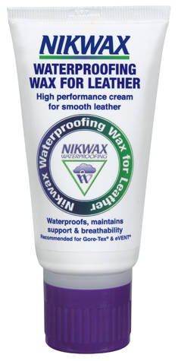
- Walking boots will either have a leather or fabric upper. Fabric boots are lighter in weight, and have a waterproof membrane inside, but needs to be regularly maintained by applying waterproofing spray or they will start to leak. Leather boots should also be cleaned and regularly waxed, but tend to withstand tougher conditions. The best time to try on boots is the afternoon as your feet may swell slightly during the day.
- Your feet will almost certainly be slightly different sizes, so try both boots on, wearing medium thick walking socks.
- All boots have a certain amount of ‘give’ in them. You should be able to wriggle your toes.
- Push your toes to the end of the boot and then put your finger down the back of the boot. If you can do this, you’ve probably got enough room for your toes to move about, but not too much so you’ll slip around inside.
- Wear your boots indoors after you buy them, and on short walks outside before the expedition.
- Tie the laces up properly and tightly.
- When on the expedition, always carry some blister pads (e.g. Compeed) – just in case!
Sleeping Bag & Roll Mat
What sleeping bag to take on an expedition? Consider the following key points
- Temperature
Range: This provides the maximum and minimum temperatures that the sleeping bag is designed for.
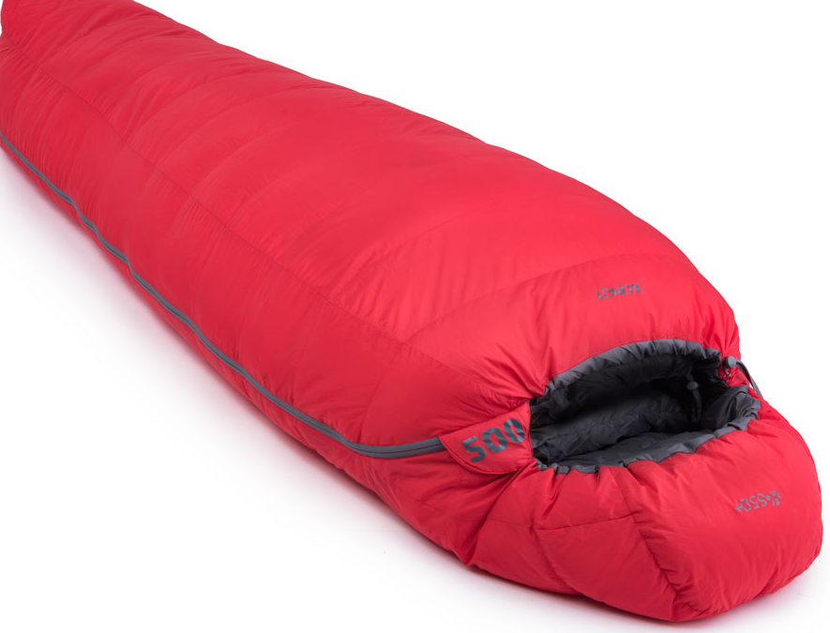
Comfort: This is the optimum temperature level that you will be warm and able to sleep in.
There is no point taking a sleeping bag suitable for arctic expeditions if it’s going to be warm. However, temperatures drop at night so thin sleeping bags made for indoor use or very hot weather are unsuitable. Think about how high you are going: if you are wild camping on a Gold expedition in the mountains, it will be much cooler than on lower ground. A 2 or 3 season sleeping bag is probably the best choice, keeping you comfortable on mild to cold nights.
- Weight - You will be carrying all your equipment so make sure your sleeping bag is lightweight too. Look for a lightweight sleeping bag between 1000-1100g.
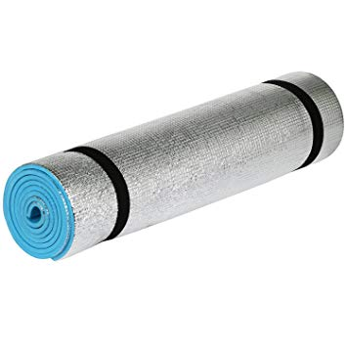
- What it is made from - Down sleeping bags are made from feathers, whereas Synthetic sleeping bags are made using polyfibres. Do NOT use down sleeping bags as they will not keep you warm if they get wet. Instead, go for a synthetic sleeping bag as they are cheaper and are more appropriate for DofE Expeditions.
- Size - You will need to pack your sleeping bag into your rucksack and still have space for all your other gear. Ensure it packs down as small as possible, and use a stuff sack or compression bag with straps that tighten to reduce the size even further.
- Comfort - If you know you tend to get cold, consider a mod el with extra insulation, and if you like to move around in your sleep, think about buying a design to maximise foot room. Consider taking an inner sheet bag, which will act as extra insulation and protect your sleeping bag.
- Cushion your sleep - A roll mat will help to insulate you from the ground, providing a degree of extra comfort and warmth. Self-insulating mats are also available although tend to be more expensive.
- Keeping your sleeping bag dry – This is vital, because not only will a wet sleeping bag make you cold and miserable all night long, it will be much heavier to carry. Pack your sleeping bag in a dry bag or sealed rubble bag to make sure the rain can’t get at it.

Packing a Rucksack

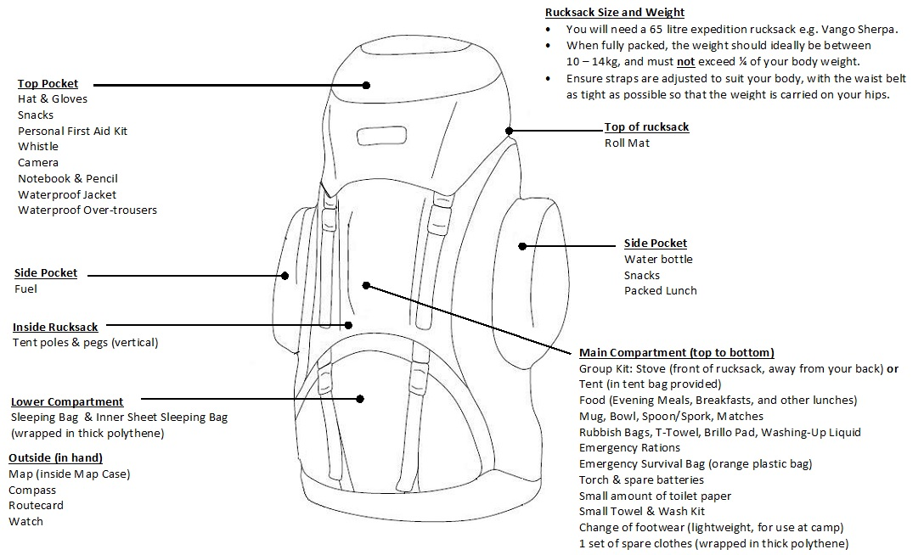

Tips
- Use rubble bag as a cheap alternative to dry bags
- You can get a free rucksack fitting at Cotswold Outdoor and 15% off with DofE.

