Breakfast | 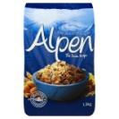 |  | 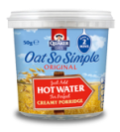 |  |  | 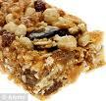 |  |  | 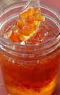 |  | 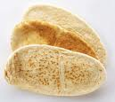 |  |  | 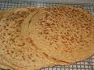 |  |  | 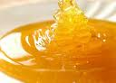
Breakfast | Muesli |  | Porridge |  |  | Cereal Bars |  |  | Marmalade |  | Pitta Bread |  |  | Oatcakes |  |  | Honey
Lunch |  |  |  |  | 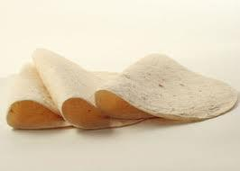 |  |  | 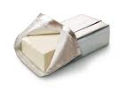 |  | 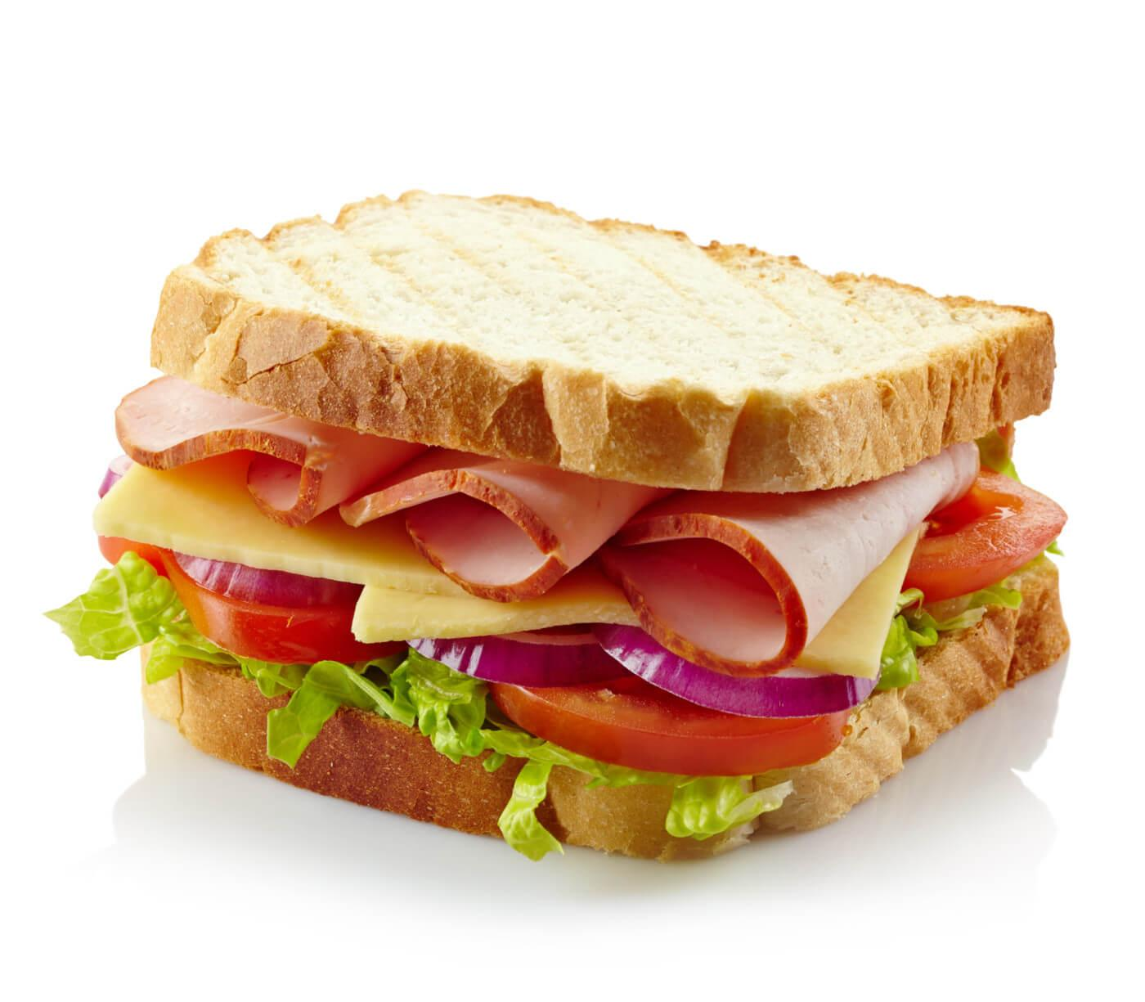 |  | 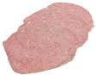 |  |  | 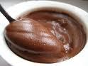 |  |  | 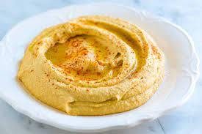
Lunch | Pitta Bread | Oatcakes |  |  | Wraps |  |  | Cheese Spread |  | Sandwiches |  | Luncheon Meat |  |  | Chocolate Spread |  |  | Hummus
Evening Meal | 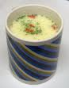 | 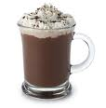 |  |  | 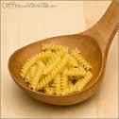 |  |  | 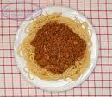 |  | 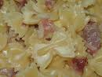 |  | 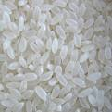 |  |  | 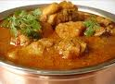 |  |  | 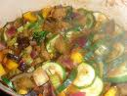
Evening Meal | Cup-a-soup | Hot Chocolate |  |  | Pasta with …. |  |  | Bolognese |  | Carbonara |  | Rice with … |  |  | Curry |  |  | Veg. Casserole
Evening Meal | 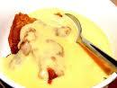 | 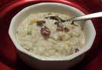 |  |  | 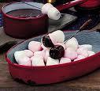 |  |  | 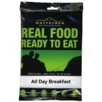 |  | 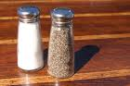 |  | 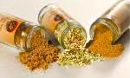 |  |  | 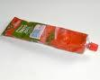 |  |  | 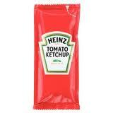
Evening Meal | Pudding & Custard | Rice Pudding |  |  | Marshmallows  & chocolate |  |  | Dehydrated Food |  | Salt & Pepper sachets |  | Herbs & Spices |  |  | Tomato Puree |  |  | Tomato Ketchup
Snacks | 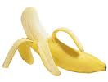 |  |  | 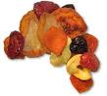 |  |  | 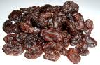 |  |  | 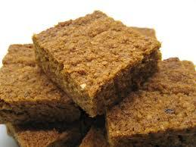 |  |  | 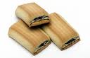 |  |  | 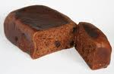
Snacks | Bananas |  |  | Dried Fruit |  |  | Raisins |  |  | Flapjacks |  |  | Fig Rolls |  |  | Malt Loaf
Snacks | 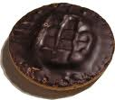 |  |  | 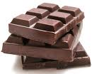 |  |  | 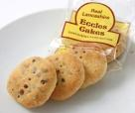 |  |  |  |  |  | 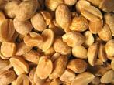 |  |  | 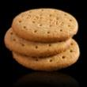
Snacks | Jaffa Cakes |  |  | Chocolate |  |  | Eccles Cakes |  |  | Pepperami |  |  | Nuts |  |  | Biscuits
Emergency rations | 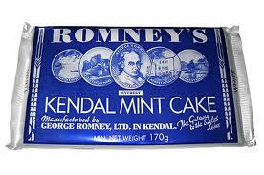  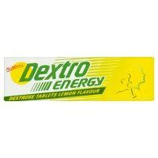  Kendal Mint Cake |  |  |  |  |  |  | Dextro Glucose Tablets |  |  |  |  |  |  | Daily Calories = 3000 kCal

Top tips for Food

- Plan your menus as a team, considering everyone’s dietary requirements and tastes.
- Consider the weight, energy, and time/fuel consumption required to cook as these are important factors.
- At Bronze, cooking pasta and rice with sauces is often the cheapest and most suitable for expeditions.
- At Silver and Gold, especially in more remote areas, specialised expedition foods may be a good alternative.
These are high in energy, simple to cook, and cuts down on the washing up!
Names:

Meal | Day 1 | Day 2 | Day 3 | Day 4
Breakfast

Breakfast | Calories = | Calories = | Calories = | Calories =
Lunch

Lunch | Calories = | Calories = | Calories = | Calories =
Evening Meal

Evening Meal | Calories = | Calories = | Calories = | Calories =
Snacks

Snacks | Calories = | Calories = | Calories = | Calories =
Total Daily Calories
Emergency rations |  |  |  | Calories =

