Orienteering Session Guides for Trainers

Basic orienteering exercises

Table Top Maps

Resources:

- Table or desk

- Several simple objects

- Paper, pencils, crayons

The Session:

- Layout some simple objects on the desk, make sure they are different shapes and sizes.

- Ask the children to imagine they are a bird flying above the desk looking down; show them what it would look like on a map. This maybe a map of pictures of the object or specific symbols to represent the different objects. Discuss what sizes the individual shapes are and how they relate in spatial positioning to each other.

- Teach them to set the map so that what is on the right on the desk is to the right on the map.

- Place the objects in a different position. Can the children draw the map of the new shapes?

- Move to a different side of the table; is the map correct now? Practice moving around the map to keep the map correctly set to match the objects.

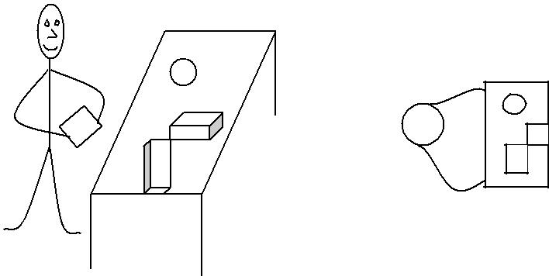

Classroom Maps
Talk about the purpose of a map.
Explain that a map is a picture that shows where things are located. Usually a map shows a place from above. Ask: What do you see from up there? What shapes do you see? Tell them that their map of the classroom will show what the room looks like from above. It will show where things in the classroom are. If helpful, project the provided image of the Classroom Map so visual and struggling learners can understand the perspective of a birds'-eye-view map.
Make a map of the classroom.
Show students the shape of the classroom drawn on butcher paper. Ask: What do you think these lines are? (the walls) What are these gaps? (door[s], windows) Ask students to add to their own maps the desks, chairs and other features in the classroom onto their map. Remind students they are looking down from above.
Then place their own location onto the map. Emphasize that a simple map of the classroom is a small model that represents something that is really much larger. Another example is a model car, which represents a much larger real car.
Have students describe where things are in the classroom.
Talk about and count other items in the classroom that can be included on the map, such as desks, chairs, carpets, or bookshelves. Place cutouts of other features or draw them on the map. As you decide what to include on the map, use the words “next to,” “near,” “far,” and “between” to describe the locations of objects. Have students repeat statements using these words or think of their own statements using the language of location.
Practice reading and using the map to follow a route.
Ask students to show how they move around in the classroom by walking their fingers on the map from one place to another. For example, have a student walk her fingers on the map from the rug to where she sits at the table. Then place sticky notes with students’ names in a few places on the map. Ask them to walk to that location. Other students can give them hints about where to go using the location words.
The following set of maps can be used for orienteering sessions in a hall/gym.

Gym Map – No controls printed on the map

Resources:

- One map from page 2 per group.

- Cones or markers to divide the hall into sections. One section per group.

The Session:

Give each group one map and allocate a section of the hall for them to work in. Ask each group to select and lay out equipment as shown on the map. Discuss and demonstrate map orientation. Pupils practice moving round the map keeping the map orientated as they progress.

Classroom Map - With controls printed for gym orienteering

Resources:

- Teacher maps for equipment and control placement from page 8.

- 7 controls lettered B, C, K, T, A, E and R

- Answer sheet

- Maps numbered 1 to 8. For a class of 30 you will need to print off 2 sets.

- Selection of gym equipment. e.g. gym mats, hoops, cones, benches.

Setting Up:

Put out gym equipment and control placement

The Session:

Issue one map per pair. Discuss map orientation and where the start is. Pupils must visit controls in order given on the map. They record answers, if correct try a different map.

Gym Score Event

Resources and Setting Up

- Same as for gym orienteering except prepare copies of the score event map on page 10 instead of the numbered map.

- Pencil and paper for each pair.

The Session:

Issue one map, pencil and paper per pair. Discuss map orientation and where the start is. Allow one minute to locate as many controls as possible and record the answers. Option to change the control letters so that when re-arranged the pupils work out an anagram.

Gym Maps - No controls Printed

Cardinal Cones Map Courses

Resources:

- 9 markers – e.g. cones,, cards pegged into the grass, each one with a north arrow and a code letter

- Large north arrow placed at the appropriate end/side of the area to be used

- Make a few (4 or 5) copies of the course maps, cut up the maps and laminate each one.

- Sets of cardinal cones maps. Put each different course map in separate bags or boxes which are clearly labelled with the course number

- Slips of paper and pencils

- Answer sheet

Preparation:

- Put out the markers in three rows of three as shown on the diagram bottom right, taking care to put the correct code in the right place according to a pre-determined plan

- Prepare an answer sheet for each course map

- For a class it may be preferable to have 2 or more sets of grids in the area so as to avoid congestion

The Session:

- A warm-up activity which revises the compass directions is a good idea e.g. all jog round and when the whistle is blown call out a direction (North, south, north east etc) and they all run to that side or corner of the area

- The children should be in pairs

- Explain that:
o The map does not show all nine cones but just the ones needed on the course

- The triangle on the map represents the start and the information on each map tells them which marker on the grid is the start place for that course

  - Each course finish point is marked on the map with a double circle and is the same as the start point

- The children should keep that map orientated so that the north lines on the map always point to the northern edge of the area (as indicated by the large north sign or arrow)

- In each pair one child is responsible for navigating whilst the other notes the code letter at each marker which is visited on the course, including the start and finish place

- Pairs come and check their answers and if correct they take a different map.

- Swap the navigating and answer writing roles each time

- Continue in this way until the time is up or everyone has completed all the maps.

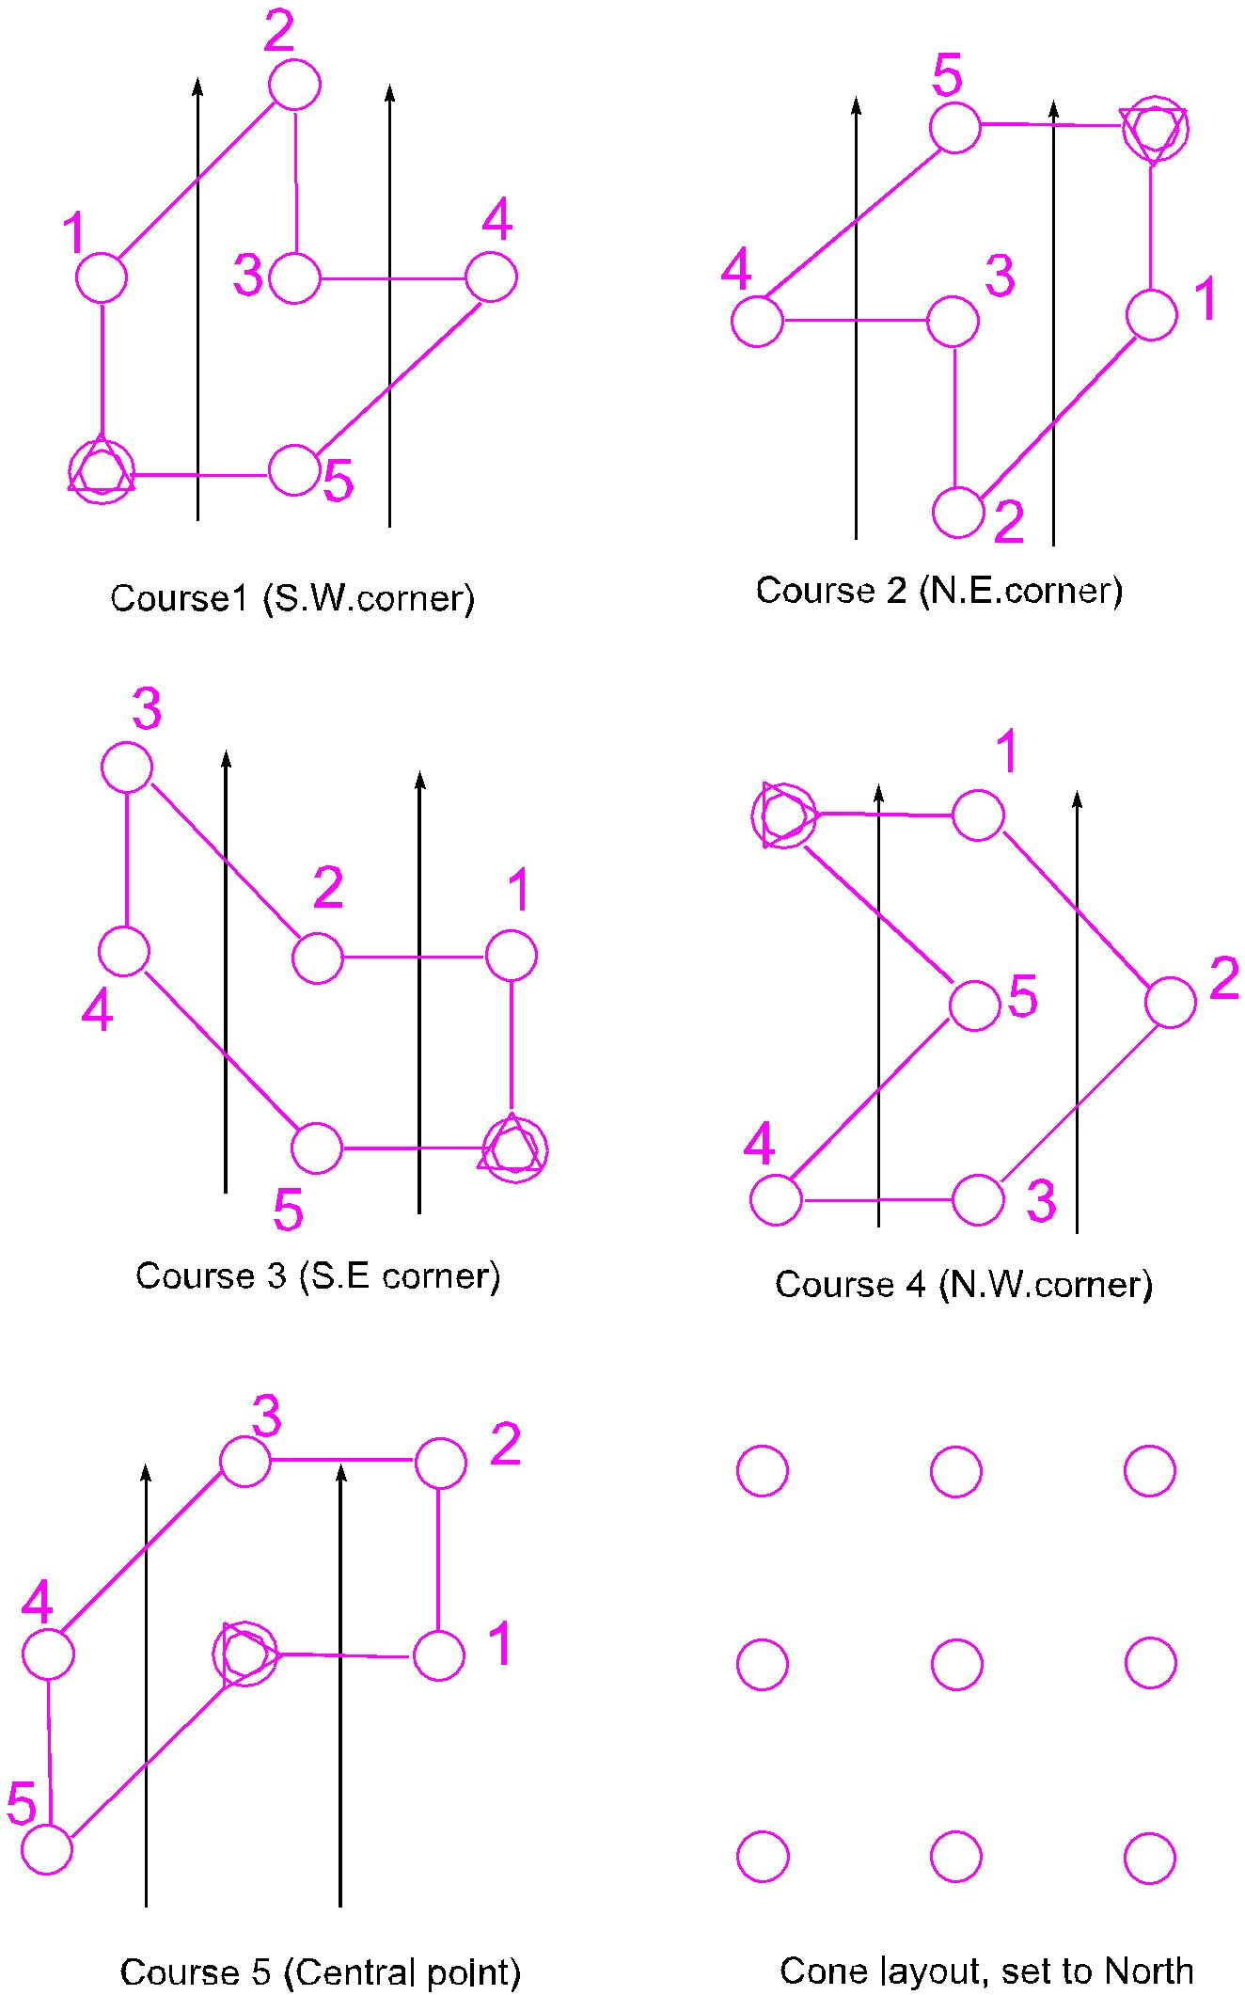

Example: Black and White Map for Extension Activity for 12 cones
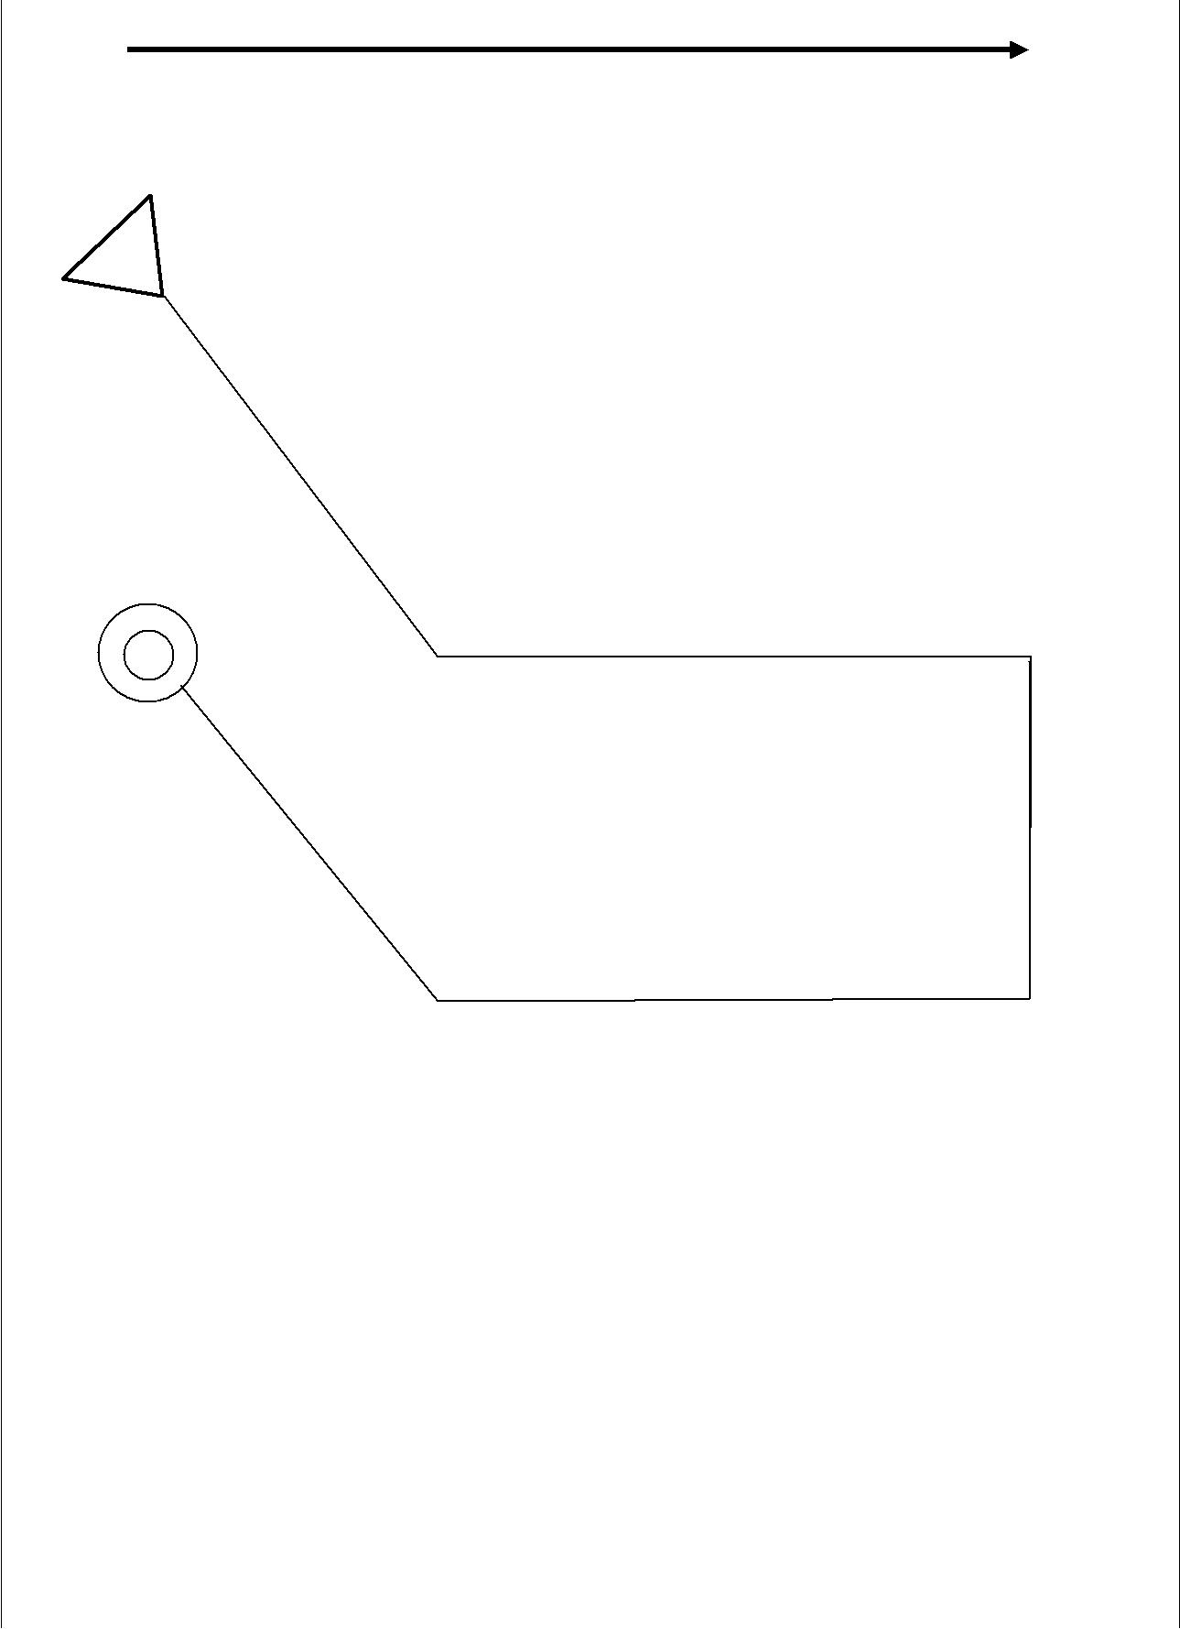

X | x | x | x
x | x | x | x
x | x | x | x

