Paracord Bracelets
You will need:
1 x buckle 1 x 1.5m long length of paracord Lighter to seal paracord
Step 1:
Fold the paracord in half. Push the folded end through the hole in one half of the buckle until the loop of paracord pokes through the other side.
Take the loose ends of the paracord and poke them through the loop of paracord then pull tight.
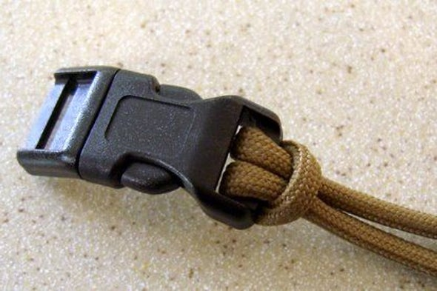
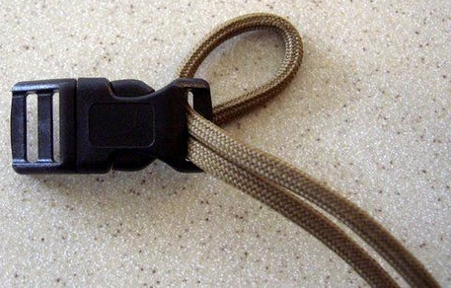

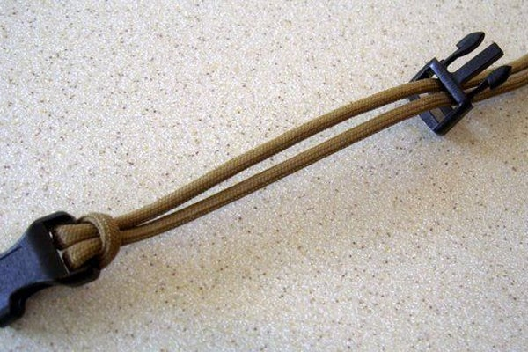
Step 2:
Unclip the buckle and push the loose ends of the paracord through the other half of the buckle.
Slide the buckle along the paracord until it sits the appropriate distance away from the other half so that it will wrap around your wrist (with about 2cm to spare).

Step 3:
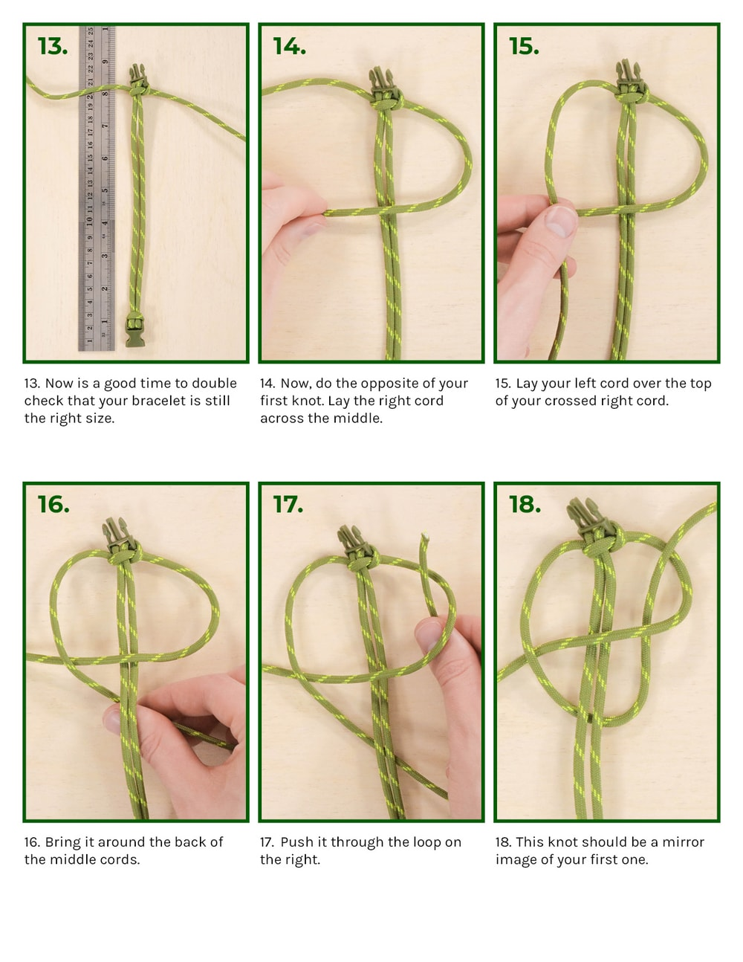
Make a P shape using the right hand single string. Then take the left hand string over the right hand one and then behind the middle two. Pull the end of the string through the P and tighten the knot.
Repeat but make a backwards P using the left hand string. Alternate with each subsequent knot.
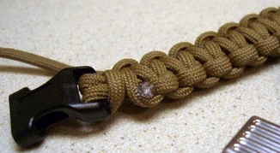
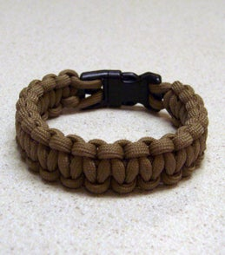
Once the knots reach the other half of the buckle trim off any excess paracord. Seal the paracord in place by melting the cut end and using the scissors (not your fingers!) to press it against the surrounding paracord.

Finished!

If you prefer to watch a video tutorial: https://www.youtube.com/watch?v=o_KeUSrmRKY

