Menu
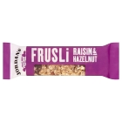
Cereal Bars
Great for snacking low in saturates, high in calories

Energy value 100g......390kCal
Carbs per 100g............64g
Fat per 100g................12.2g
Protein per 100g..........5.8g
Packability....................Good

Menu
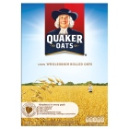Porridge Oats
Excellent! Make with water and add honey for a bigger calorie punch

Energy value 100g......374kCal
Carbs per 100g............60g
Fat per 100g................8g
Protein per 100g..........11g
Packability....................Good

Menu
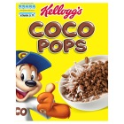
Coco Pops
Difficult to carry and high in sugar

Energy value 100g......387kCal
Carbs per 100g............87g
Fat per 100g................2.5g
Protein per 100g..........2.5g
Packability....................Poor

Menu
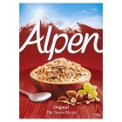
MUESLI
Rocket fuel! mix with water and powdered milk for a good start to the day

Energy value 100g......377kCal
Carbs per 100g............66.8g
Fat per 100g................5.8g
Protein per 100g.........5g
Packability....................Good

Menu
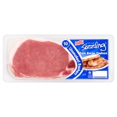
Bacon
Makes a mess of your pans and no carbs, difficult to keep fresh

Energy value 100g......282kCal
Carbs per 100g............0.1g
Fat per 100g................19.6g
Protein per 100g........26.3g
Packability....................Poor

Menu
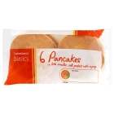
Pancakes
If you can’t eat porridge ok alternative with honey or Jam

Energy value 100g......258kCal
Carbs per 100g............48g
Fat per 100g................5.1g
Protein per 100g..........4.8g
Packability....................OK

Menu
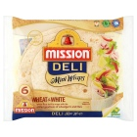
Wraps
Brilliant for lunches can be filled with anything

Energy value 100g......314kCal
Carbs per 100g............47.1g
Fat per 100g................9.4g
Protein per 100g.........7.8g
Packability....................Good

Menu
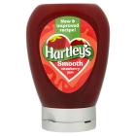
Squeezy Jam
Great in wraps, on porridge or pancakes for extra calories

Energy value 100g......251kCal
Carbs per 100g............61.4g
Fat per 100g................0.2g
Protein per 100g........0.4g
Packability..................OK



Menu
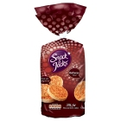
Rice Cakes
Great for snacking, high in carbs

Energy value 100g......382kCal
Carbs per 100g............81.6g
Fat per 100g................2.2g
Protein per 100g.........7.8g
Packability....................OK

Menu
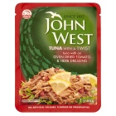
Tuna
Buy in sachets and use in wraps or add to rice or pasta
Energy value 100g......160kCal
Carbs per 100g............3.9g
Fat per 100g................8.0g
Protein per 100g.........18.0g
Packability....................Good

Menu
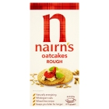
Oat Cakes
Great for snacking, low GI

Energy value 100g......431kCal.
Carbs per 100g............58.6g
Fat per 100g................17.3g
Protein per 100g..........10.2g
Packability....................OK

Menu
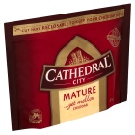
Cheese
High energy values but all from fats.

Energy value 100g......416kCal
Carbs per 100g............0.1g
Fat per 100g................34.9g
Protein per 100g.........25.4g
Packability....................Good

Menu
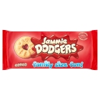
Biscuits
Nice treat! Choose harder varieties to avoid packet of crumbs.

Energy value 100g......420kCal
Carbs per 100g............72.4g
Fat per 100g................11.7g
Protein per 100g.........5.7g
Packability....................OK

Menu
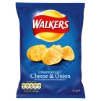
Crisps
Usually ends up as crumbs! High in fat and salt.

Energy value 100g......520kCal
Carbs per 100g............52.g
Fat per 100g................30.6g
Protein per 100g..........6.3g
Packability....................Poor

Menu
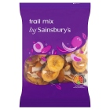
Trail Mix (nuts &fruit)
For nut allergies dried fruit good option.

Energy value 100g......404kCal
Carbs per 100g............38.5g
Fat per 100g................23.7g
Protein per 100g.........7.0g
Packability....................Good

Menu
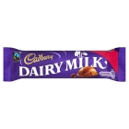
Chocolate
mmmmm..but all carbs from sugar, Never mind a bit of what you fancy is good. Melts in warm weather

Energy value 100g......530kCal
Carbs per 100g............57g
Fat per 100g................29.8g
Protein per 100g.........7.5g
Packability....................OK

Menu
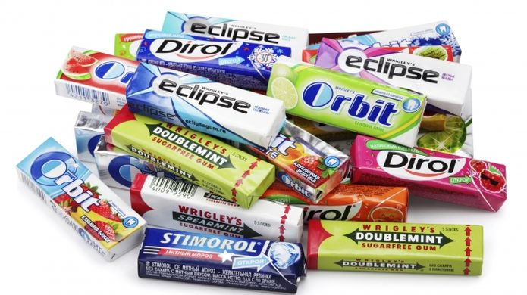

Chewing gum

ABSOLUTELY NOT
Zero nutritional value, and very difficult to dispose of responsibly. Leave it at home.

Menu
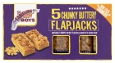

Flapjack
High in fat, high in carbs & high in energy...taste good too!

Energy value 100g......466kCal
Carbs per 100g............58.8g
Fat per 100g................22g
Protein per 100g..........5.7g
Packability....................Good

Menu
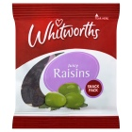
Dried fruit
Great for snacking or adding to porridge, Much better for you than a packet of crisps.

Energy value 100g.....105kCal.
Carbs per 100g............23.6g
Fat per 100g................0.2g
Protein per 100g.........1.1g
Packability....................Good

Menu
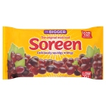
Malt Loaf
Great hill food! Doesn’t matter if it gets squashed!

Energy value 100g......303kCal
Carbs per 100g............65.1g
Fat per 100g................1.8g
Protein per 100g.........7.2g
Packability....................Good

Menu
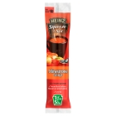
Concentrated Soup
Quick easy and tasty

Energy value 100g......133kCal
Carbs per 100g............5.0g
Fat per 100g................0.7g
Protein per 100g.........0.8g
Packability....................Good
Menu
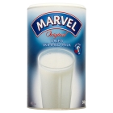
Powdered Milk
Add to porridge and cereals if you need it. Decant into zip lock bags

Energy value 100g......348kCal
Carbs per 100g............52.9g
Fat per 100g................0.6g
Protein per 100g........36.10
Packability....................OK

Menu
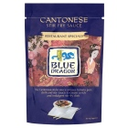
Stir Fry Sauce
Ad to veggies to make a proper stir fry or just add to rice or pasta

Energy value 100g......133kCal
Carbs per 100g............30.4g
Fat per 100g.................0.6g
Protein per 100g..........0.8g
Packability....................Good

Menu
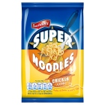
Super Noodles
Not as good as dried pasta and needs additional ingredients to make a meal but....not awful.

Energy value 100g.....176kCal
Carbs per 100g............34.5g
Fat per 100g................11.8g
Protein per 100g.........4.7g
Packability....................Good

Menu
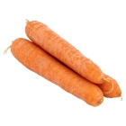
Fresh Veggies
Best option for taste and health but can take a long time to prepare and cook
Energy value 100g......various
Carbs per 100g............various
Fat per 100g................various
Packability....................Good

Menu
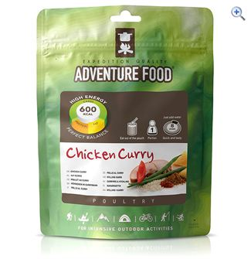
Dried Ready Meals
Just add boiling water and stir but expensive and some taste poor

Energy value 100g......450kCal
Carbs per 100g............68g
Fat per 100g................9.8g
Protein per 100g.........12.0.
Packability....................Good

Menu
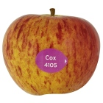
Apples
Easy to pack and good fibre an micro nutrients..taste good

Energy value 100g......47kCal
Carbs per 100g............12g
Fat per 100g................0.5g
Protein per 100g.........0.5g
Packability...................OK.

Menu
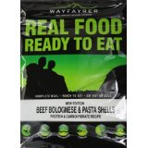
Wayfarer Ready Meals
No washing up but heavy and expensive

Energy value 100g......136kCal
Carbs per 100g............13.2g
Fat per 100g................6.6g
Protein per 100g.........5.9g
Packability....................Good

Menu
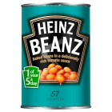
Baked Beans
Yum...but cans are very heavy!

Energy value 100g......79kCal
Carbs per 100g............12.9g
Fat per 100g................0.2g
Protein per 100g.........4.7g
Packability....................Poor

Menu
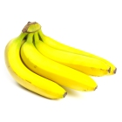
Bananas
Tend to squish up in your bag. Packets of dried good alternative

Energy value 100g.....103kCal.
Carbs per 100g............23g
Fat per 100g................0.5g
Protein per 100g.........1.2g
Packability....................poor

Menu
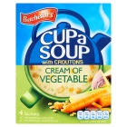
Cup Soups
Easy hot drink

Energy value 100g......54kCal
Carbs per 100g............6.6g
Fat per 100g................2.5g
Protein per 100g.........0.7g
Packability....................Good

Menu
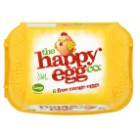
Eggs
Rubbish packaging

Energy value 100g......151kCal
Carbs per 100g............Trace
Fat per 100g................11.2g
Protein per 100g.........12g
Packability....................very poor

Menu
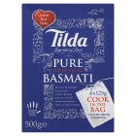
Rice
Boil in the bag for convenience but more expensive

Energy value 100g......192kCal
Carbs per 100g............41.7g
Fat per 100g................0.6g
Protein per 100g.........5.1g
Packability....................Good

Menu
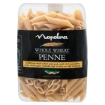
Whole Wheat Pasta
Food of Champs. High carb to replace lost energy. Just cook and add favourite sauce

Energy value 100g.....362kCal.
Carbs per 100g............73.1g
Fat per 100g................1.7g
Protein per 100g.........12.3g
Packability....................Good

Menu
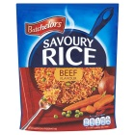
Savoury Rice
Easy to cook tastes ok. Can be used as a base for other ingredients

Energy value 100g......129kCal
Carbs per 100g...........26.6g.
Fat per 100g................0.8g
Protein per 100g........3.2g
Packability....................Good

Menu
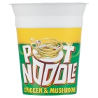
Pot Noodle
Arrgh! High in salt low in good stuff! Why would you?

Energy value 100g......131kCal
Carbs per 100g............19g
Fat per 100g................4.g
Protein per 100g.........3.3g
Packability....................Poor

Menu
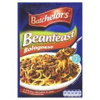
Soya Mince (Bean Feast)
Tasty, convenient good addition to pasta but high in salt.

Energy value 100g......310kCal
Carbs per 100g............38.2g
Fat per 100g................6.1g
Protein per 100g..........25.6g
Packability....................Good

Menu
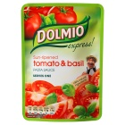
Pasta Sauces
Plenty to choose from. Sachets only, never glass jars.

Energy value 100g......49kCAL
Carbs per 100g............8.1G
Fat per 100g................1.2G
Protein per 100g..........1.1g
Packability....................Good

Menu
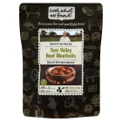
Look What We Found
Ready meals in a bag! Tasty but heavy and low in carbs. Would need to mix with a starch

Energy value 100g......107kCal
Carbs per 100g............7.8g
Fat per 100g................3.8g
Protein per 100g.........9.3g
Packability....................Good

Menu
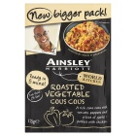
Cous Cous
Easy to cook, tastes ok and can be added to.

Energy value 100g......144kCal
Carbs per 100g............27.4g
Fat per 100g................1.2g
Protein per 100g.........5.3g
Packability....................Good

Menu
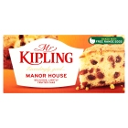
Fruit Cake
Great with a brew when you get into camp.

Energy value 100g......$02kCal
Carbs per 100g............50.4g
Fat per 100g................19.7g
Protein per 100g..........5.2g
Packability....................OK

Menu
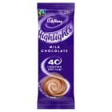
Hot Chocolate
Easy, quick and tasty hot drink

Energy value 100g......380kCal
Carbs per 100g............46.9g
Fat per 100g................13.1g
Protein per 100g..........16.8g
Packability....................Good

Menu
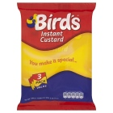
Instant Custard
Can be messy and really high in sugar but great poured over a slice of cake!
Energy value 100g......424kCal
Carbs per 100g............76.7g
Fat per 100g................11.2g
Protein per 100g.........4.2g
Packability....................Good

Menu
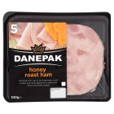
Sandwich Meats
High protein but difficult to keep fresh best for day 1 lunch
(Ham)
Energy value 100g......107kCal
Carbs per 100g............0.7g
Fat per 100g................3.0g
Protein per 100g.........19.4g
Packability....................ok

Menu
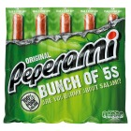
Pepperami
High in fat but can be used to add protein to pasta and rice meals.
Energy value 100g.....504kCal.
Carbs per 100g............2.5g
Fat per 100g................44g
Protein per 100g.........24g
Packability....................Good

Menu
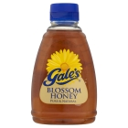
Squeezy Honey
Great in wraps, with cheese, on porridge or in hot drinks.

Energy value 100g......352kCal
Carbs per 100g............87.1g
Fat per 100g................0.3g
Protein per 100g..........0.3g
Packability....................Good

Menu

Squeezy Cheese
Great in wraps, needs to be kept cool

Energy value 100g......210kCal
Carbs per 100g............3.9g
Fat per 100g................16g
Protein per 100g..........13g
Packability....................Good

Menu
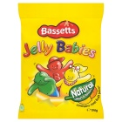
Jelly Babies
Made with sugar and glucose syrup so take in moderation. Not for veggies.

Energy value 100g......335kCal
Carbs per 100g............79.7g
Fat per 100g................Trace
Protein per 100g.........3.5g
Packability....................Good

